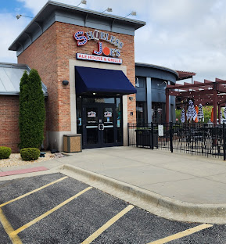
Award Banquet
March 13, 2026
7:30-10:00 pm
Shoeless Joes Ale House & Grille
1480 W Lake Street
Addison, Il
Club will provide pizza and soda.
If you would like to bring a dessert that’s okay
Please RSVP Kathy at kathykaminski@att.net by March 9, 2026
RSVP is required for there to be enough food!

